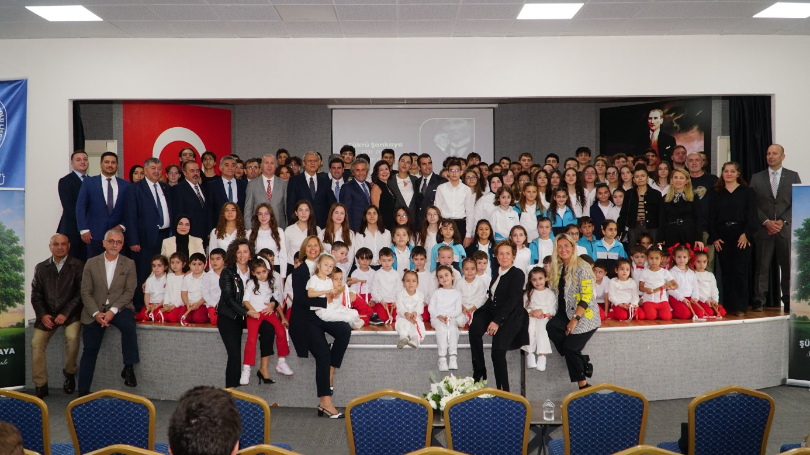

**October 10, 2025**

**A Meaningful Commemoration for Şükrü Şankaya**

**The late Şükrü Şankaya, a pioneer of Bursa’s industrial development, was commemorated with a heartfelt ceremony marking the 20th anniversary of his passing.**

A special remembrance event was held at Şükrü Şankaya Anatolian High School to honor the memory of the late founder of Yeşim Group, Şükrü Şankaya. The ceremony once again highlighted Şankaya’s deep commitment to education and people. Among the attendees were Osmangazi District Governor Ali Partal, Acting District Director of National Education Hasan Ali Tüzel, Regional Director of Forestry Erdal Şahan, Provincial Director of National Education Branch Manager Mehmet Zorlu, District Director of National Education Branch Manager Asım Bulut, Yeşim Group CEO Şenol Şankaya, members of the Şankaya Family, students from Şükrü Şankaya Anatolian High School and Şükrü Şankaya Primary School, Yeşim Sports Head Coach and Director Cem Çağal, Yeşim Sports athletes, Turkish Education Foundation (TEV) Bursa Branch Donor Relations Officer Kadircan Şentürk, TEV scholarship students, and many other guests. The emotional ceremony once again reminded participants of Şükrü Şankaya’s “people first” philosophy, his unwavering belief in education, and the lasting values he passed on to future generations.

The program began with welcome speeches by Şükrü Şankaya Anatolian High School Principal Yeşim Ömeroğlu Ünlü and Şükrü Şankaya Primary School Principal Mehmet Nüsret Arğan. Both speakers emphasized that Şükrü Şankaya devoted his life to supporting young people, viewed education as the cornerstone of a nation’s future, and that his “people first” mindset continues to guide students’ development today.

Yeşim Group CEO Şenol Şankaya delivered an emotional speech reflecting on his father’s life philosophy and approach to education: “Today, we are not only remembering my father but also honoring his human-centered leadership, his mentoring spirit, and the values he brought to life. He placed people at the heart of every success he achieved in business and inspired society as well as the business world through his investments in education and youth development. Continuing his vision is a source of immeasurable pride for us. My father’s belief in supporting children’s and young people’s education extended from preschool to university. The Şükrü Şankaya Fund, which we established in 2005 in collaboration with the Turkish Education Foundation, is one of the most concrete examples of his vision carried into the future. Supporting young women’s education through this fund is the greatest investment in our country’s future. I am also proud to share that Şükrü Şankaya Anatolian High School’s acceptance into the International Baccalaureate (IB) Diploma Programme is another significant step that carries his educational philosophy forward. Through this program, our students will grow into academically accomplished individuals with a global mindset and a strong sense of curiosity and understanding.”

Osmangazi District Governor Ali Partal also delivered a speech at the ceremony, stating: “It is truly valuable that the schools established by the late Şükrü Şankaya continue to thrive with the ongoing support of the Şankaya Family. Particularly, Şükrü Şankaya Anatolian High School’s inclusion as a pilot school in the International Baccalaureate Programme—a global model of education—is a remarkable example of how his educational vision is being translated into reality for younger generations. I would like to express my gratitude to the Şankaya Family for these meaningful contributions.”

One of Şükrü Şankaya’s most enduring legacies, Yeşim Kindergarten, which has provided continuous service for 37 years, was featured in a documentary that deeply moved the audience. The film portrayed Yeşim Kindergarten not merely as an educational institution but as a nurturing environment instilling children with values of love, sharing, and responsibility. The dance performances prepared by the nursery students for the ceremony both entertained and touched the audience.

Students from Şükrü Şankaya Anatolian High School received great applause for their musical performances, which reflected their gratitude and commitment to Şükrü Şankaya’s values. TEV scholarship recipients also expressed their appreciation to the Şankaya Family, emphasizing the legacy of kindness that underlies the educational opportunities they have received.

As part of the ceremony, students from Şükrü Şankaya Primary School shared heartfelt letters dedicated to Şükrü Şankaya. The winners of the letter-writing contest were Melisa Kayla Polat (1st place), Yağmur Kara (2nd place), and Müberra Melek Sunay (3rd place). Their awards were presented by Osmangazi District Governor Ali Partal and Yeşim Group CEO Şenol Şankaya.

At the conclusion of the program, a portrait of Şükrü Şankaya prepared by the students of Şükrü Şankaya Anatolian High School was presented to Şenol Şankaya as a token of appreciation.

Yeşim Group continues to uphold the “people first” philosophy of its founder through its ongoing initiatives in education, social responsibility, and sustainable development by carrying forward Şükrü Şankaya’s enduring legacy of valuing people for generations to come.